Assignment 25.5

Problem Statement:
1. Write a hive query to list top 5 residency details which lie in the budget of 60000-120000, an area more than 1450, sold after 17th may, min bedroom 3 and, min bathroom 2.
2. Write a hive query to separate list of residential apartments with more than 2 beds. Also include columns in following order City, Baths,Sq_feet,Price,flat_type,Beds respectively.

Input:
You can download the dataset from the link below: https://drive.google.com/file/d/0B1QaXx7tpw3SNDVoWEhPTk1SSjQ/view
The first line of the dataset is the dataset description.

Output:

Creating table real_state in custom database and loading real_state data into the table:

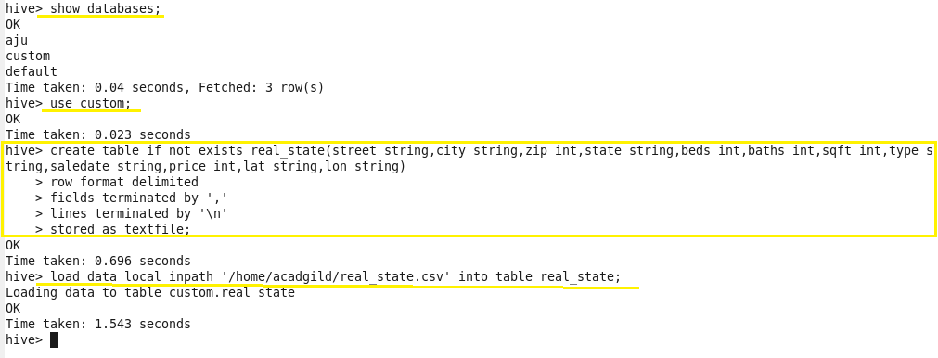

Problem 1:
Write a hive query to list top 5 residency details which lie in the budget of 60000-120000, an area more than 1450, sold after 17th may, min bedroom 3 and, min bathroom 2.

Output 1:

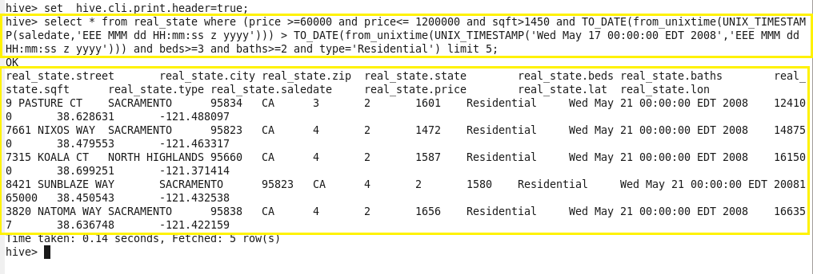

Problem 2:
Write a hive query to separate list of residential apartments with more than 2 beds. Also include columns in following order City, Baths, Sq_feet, Price, flat_type, Beds respectively.

Output 2:

